// gece2uy1.cpp : This file contains the 'main' function. Program execution begins and ends there.

//

#include <iostream>

#include<cmath>

#include<iomanip>

using namespace std;

int main()

{

int sayi1, sayi2, secim;

cout << " sayi 1 ? "; cin >> sayi1;

cout << " sayi 2 ? "; cin >> sayi2;

cout << "\t Ne yapalım?"<< endl;

cout << "\t 1 toplama " << endl;

cout << "\t 2 cikarma " << endl;

cout << "\t 3 carpma " << endl;

cout << "\t 4 bolme " << endl;

cout << "\t 5 kalan " << endl;

cout << " seciminiz? (1-5) "; cin >> secim;

if(secim==1)

{

cout << sayi1 << " + " << sayi2 << " = " << sayi1 + sayi2<<endl;

}

if (secim == 2)

{

cout << sayi1 << " - " << sayi2 << " = " << sayi1 - sayi2<<endl;

}

if (secim == 3)

{

cout << sayi1 << " * " << sayi2 << " = " << sayi1 * sayi2 << endl;

}

if (secim == 4)

{

if (sayi2 != 0)

cout << sayi1 << " / " << sayi2 << " = " << (float)sayi1 / sayi2 << endl;

else

cout << " sifira bolme olmaz" << endl;

}

if (secim == 5)

{

cout << sayi1 << " mod " << sayi2 << " = " << sayi1 % sayi2 << endl;

}

return 0;

}

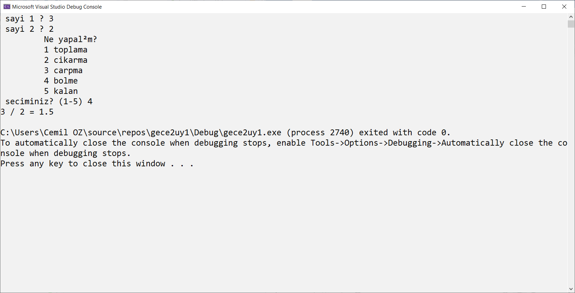  
// gece2uy1.cpp : This file contains the 'main' function. Program execution begins and ends there.

//

#include <iostream>

using namespace std;

int main()

{

int sayi1, sayi2, secim;

cout << " sayi 1 ? "; cin >> sayi1;

cout << " sayi 2 ? "; cin >> sayi2;

cout << "\t Ne yapalım?"<< endl;

cout << "\t 1 toplama " << endl;

cout << "\t 2 cikarma " << endl;

cout << "\t 3 carpma " << endl;

cout << "\t 4 bolme " << endl;

cout << "\t 5 kalan " << endl;

cout << " seciminiz? (1-5) "; cin >> secim;

if(secim==1)

{

cout << sayi1 << " + " << sayi2 << " = " << sayi1 + sayi2<<endl;

}

else if (secim == 2)

{

cout << sayi1 << " - " << sayi2 << " = " << sayi1 - sayi2<<endl;

}

else if (secim == 3)

{

cout << sayi1 << " * " << sayi2 << " = " << sayi1 * sayi2 << endl;

}

else if (secim == 4)

{

if (sayi2 != 0)

cout << sayi1 << " / " << sayi2 << " = " << (float)sayi1 / sayi2 << endl;

else

cout << " sifira bolme olmaz" << endl;

}

else if (secim == 5)

{

cout << sayi1 << " mod " << sayi2 << " = " << sayi1 % sayi2 << endl;

}

else

{

cout << " please select correct item ..." << endl;

}

return 0;

}

// gece2uy1.cpp : This file contains the 'main' function. Program execution begins and ends there.

//

#include <iostream>

using namespace std;

int main()

{

int sayi1, sayi2, secim;

cout << " sayi 1 ? "; cin >> sayi1;

cout << " sayi 2 ? "; cin >> sayi2;

cout << "\t Ne yapalım?"<< endl;

cout << "\t 1 toplama " << endl;

cout << "\t 2 cikarma " << endl;

cout << "\t 3 carpma " << endl;

cout << "\t 4 bolme " << endl;

cout << "\t 5 kalan " << endl;

cout << " seciminiz? (1-5) "; cin >> secim;

switch (secim )

{

case 1:

cout << sayi1 << " + " << sayi2 << " = " << sayi1 + sayi2 << endl;

break;

case 2:

cout << sayi1 << " - " << sayi2 << " = " << sayi1 - sayi2 << endl;

break;

case 3:

cout << sayi1 << " * " << sayi2 << " = " << sayi1 * sayi2 << endl;

break;

case 4:

if (sayi2 != 0)

cout << sayi1 << " / " << sayi2 << " = " << (float)sayi1 / sayi2 << endl;

else

cout << " sifira bolme olmaz" << endl;

break;

case 5:

cout << sayi1 << " mod " << sayi2 << " = " << sayi1 % sayi2 << endl;

break;

default:

cout << " please select correct item ..." << endl;

}

return 0;

}

// gece2uy1.cpp : This file contains the 'main' function. Program execution begins and ends there.

//

#include <iostream>

#include <cmath>

#include <iomanip>

using namespace std;

int main()

{

float angleDegre;

float radyanDegre;

const float pi = 3.141516f;

cout << setw(10) << "angle Degre" << setw(12) << "sin value" << endl;

for (angleDegre = 0; angleDegre <= 360; angleDegre += 20)

{

radyanDegre = pi * angleDegre / 180;

cout << setw(10) << angleDegre << setw(12) << sin(radyanDegre) << endl;

}

return 0;

}

// gece2uy1.cpp : This file contains the 'main' function. Program execution begins and ends there.

//

#include <iostream>

using namespace std;

float sum(float , float ); // decleration user function

float sub(float a, float b); //decleration user function

int main()

{

float number1, number2;

cout << "eneter number1? "; cin >> number1;

cout << "eneter number2? "; cin >> number2;

float sum1 = sum(number1, number2); //call or invoke user function

cout << "sum ="<<sum1<<endl;

cout << "sub =" << sub(number1, number2) << endl; //call or invoke user function

return 0;

}

float sum(float a, float b) // user function

{

float result = a + b;

return result;

}

float sub(float a, float b) // user function

{

float result = a - b;

return result;

}

#include <iostream>

using namespace std;

float sum(float a, float b);

float sub(float , float );

float mul(float, float);

float div(float, float);

int main()

{

float sayi1, sayi2;

int secim;

char ch = 'a';

do

{

do

{

system("CLS");

cout << " sayi 1 ? "; cin >> sayi1;

cout << " sayi 2 ? "; cin >> sayi2;

cout << "\t Ne yapalım?" << endl;

cout << "\t 1 toplama " << endl;

cout << "\t 2 cikarma " << endl;

cout << "\t 3 carpma " << endl;

cout << "\t 4 bolme " << endl;

cout << " seciminiz? (1-4) "; cin >> secim;

} while (secim < 1 || secim > 4);

switch (secim)

{

case 1:

cout << "sum of a and b " << sum(sayi1, sayi2) << endl;

break;

case 2:

cout << "dif of a and b " << sub(sayi1, sayi2) << endl;

break;

case 3:

cout << "multiplication of a and b " << mul(sayi1, sayi2) << endl;

break;

case 4:

cout << "divison of a with b " << div(sayi1, sayi2) << endl;

break;

default:

cout << " please select items between 1 and 4" << endl;

break;

}

cout << " do you want to continue ?(y/n) "; cin >> ch;

} while (ch!='n'|| ch!='N');

return 0;

}

float sum(float a, float b) // user function

{

float result = a + b;

return result;

}

float sub(float a, float b) // user function

{

float result = a - b;

return result;

}

float mul(float a, float b) // user function

{

float result = a * b;

return result;

}

float div(float a, float b) // user function

{

if (b != 0)

{

float result = a - b;

return result;

}

return 0.0f;

}

#include <iostream>

using namespace std;

int main()

{

float sayi1, sayi2;

int secim;

char ch = 'a';

do

{

do

{

system("CLS");

cout << " sayi 1 ? "; cin >> sayi1;

cout << " sayi 2 ? "; cin >> sayi2;

cout << "\t Ne yapalım?" << endl;

cout << "\t 1 toplama " << endl;

cout << "\t 2 cikarma " << endl;

cout << "\t 3 carpma " << endl;

cout << "\t 4 bolme " << endl;

cout << "\t 5 kalan " << endl;

cout << " seciminiz? (1-5) "; cin >> secim;

} while (secim < 1 || secim > 5);

switch (secim)

{

case 1:

cout << sayi1 << " + " << sayi2 << " = " << sayi1 + sayi2 << endl;

break;

case 2:

cout << sayi1 << " - " << sayi2 << " = " << sayi1 - sayi2 << endl;

break;

case 3:

cout << sayi1 << " * " << sayi2 << " = " << sayi1 * sayi2 << endl;

break;

case 4:

if (sayi2 != 0)

cout << sayi1 << " / " << sayi2 << " = " << (float)sayi1 / sayi2 << endl;

else

cout << " sifira bolme olmaz" << endl;

break;

case 5:

cout << sayi1 << " mod " << sayi2 << " = " << (int)sayi1 % (int)sayi2 << endl;

break;

default:

cout << " select correct item ..." << endl;

}

cout << " baska işlem yapilacak mı ?(y/n) "; cin >> ch;

} while (ch!='n');

return 0;

}

#include <iostream>

#include <iomanip>

using namespace std;

int main()

{

for (int i = 1; i <= 10; i++)

{

system("cls);

for (int j = 0; j <= 10; j++)

{

cout <<setw(2)<< i << "*" <<setw(2)<< j << "=" <<setw(3)<< i * j << endl;

}

cout << "\n *******************\n";

system("pause");

}

}

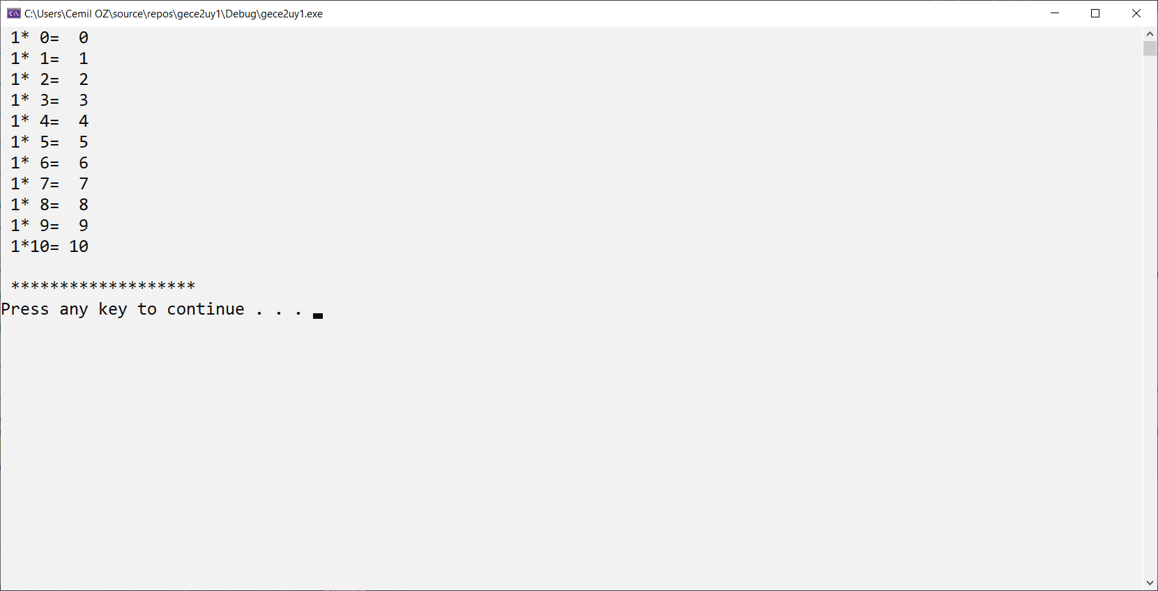

#include <iostream>

#include <iomanip>

using namespace std;

int main()

{

int i, j;

for (i = 0; i <= 5; i++)

{

for (j = 5-i; j>= 0; j--)

cout << " ";

for (j = 0; j <= i; j++)

cout << "*";

cout <<" ";

for (j = 0; j <= i; j++)

cout << "*";

cout << endl;

}

}

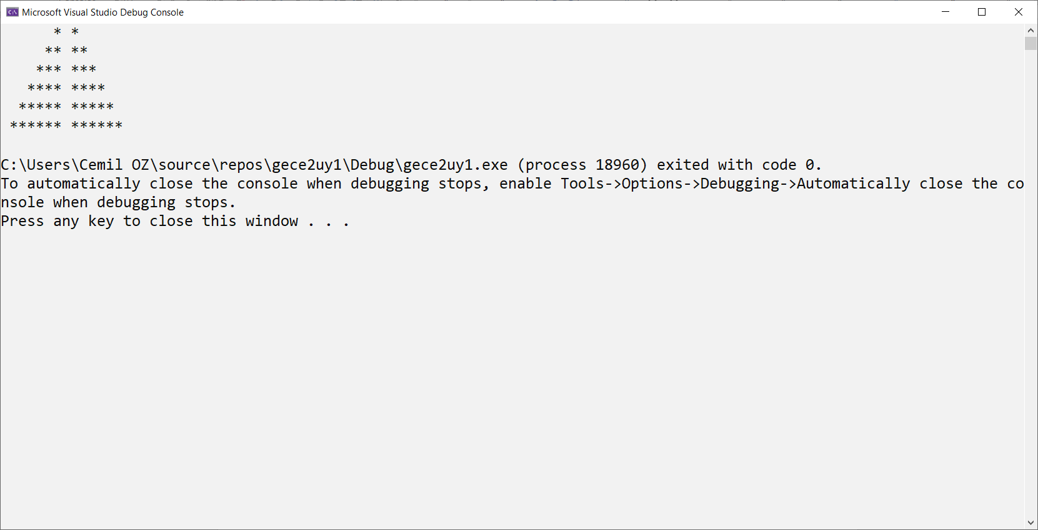

#include <iostream>

using namespace std;

int main()

{

const int element = 100;

int a[element];

char control = 'a';

int n;

do

{

do {

system("cls");

cout << " how many element (max " << element << " 100) ?";

cin >> n;

} while (!(n >= 0 && n <= 100));

for (int i = 0; i < n; i++)

{

a[i]=rand()%100; // rasgele sayı oluşturma

}

for (int i = 0; i < n; i++)

{

cout << " a[" << i << "]=" << a[i] << endl;

}

cout << "do you want to enter another array data? (y/n)"; cin >> control;

} while (!(control == 'n' || control == 'N'));

return 0;

}

#include <iostream>

using namespace std;

int main()

{

const int element = 100;

int a[element];

char control = 'a';

int n;

do

{

do {

system("cls");

cout << " how many element (max " << element << " 100) ?";

cin >> n;

} while (!(n >= 0 && n <= 100));

for (int i = 0; i < n; i++)

{

cout << " a[" << i << "]=";

cin >> a[i];

}

for (int i = 0; i < n; i++)

{

cout << " a[" << i << "]=" << a[i] << endl;

}

cout << "do you want to enter another array data? (y/n)"; cin >> control;

} while (!(control == 'n' || control == 'N'));

return 0;

}

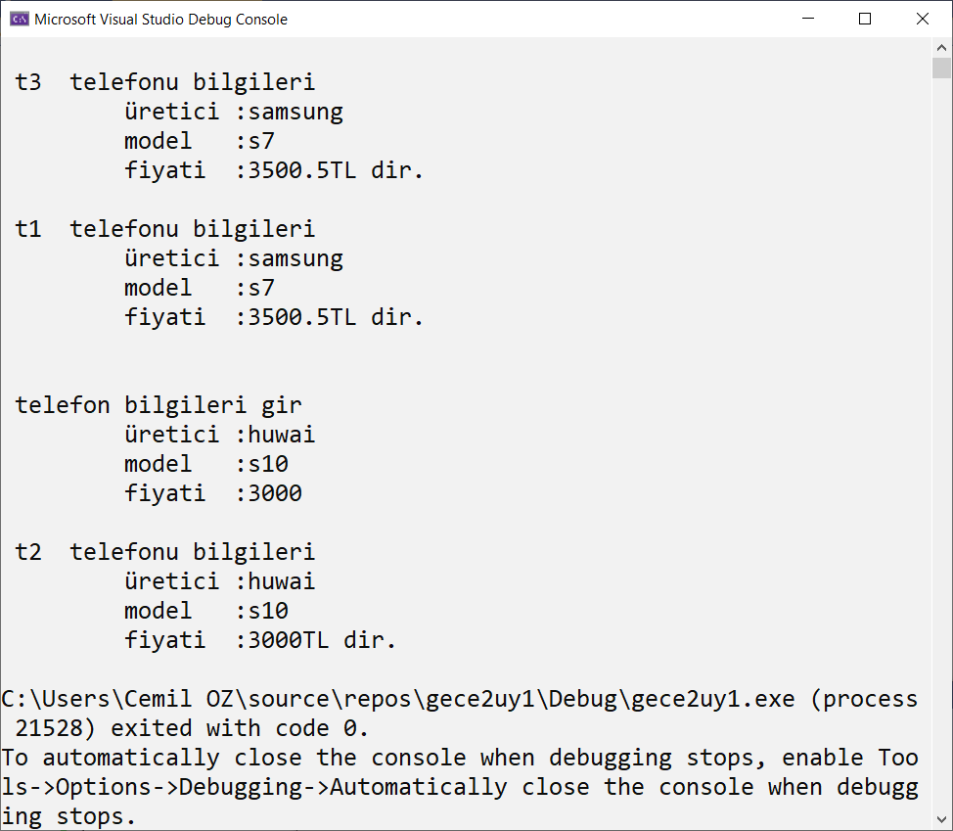

#include <iostream>

#include <locale.h>

using namespace std;

struct cepTelefonu

{

string uretici;

string model;

float fiyat;

};

void yazdir(cepTelefonu t, string s); //fonksiyon bildirimi

cepTelefonu oku();

int main()

{

setlocale(LC_ALL, "Turkish");

cepTelefonu t1, t2;

cepTelefonu t3 = { "samsung","s7",3500.50f };

yazdir(t3, " t3 ");

t1 = t3;

yazdir(t1, " t1 ");

t2 = oku();

yazdir(t2, " t2 ");

return 0;

}

cepTelefonu oku()

{

cepTelefonu t;

cout << "\n\n telefon bilgileri gir " << endl;

cout << "\t üretici :"; cin >> t.uretici;

cout << "\t model :"; cin >> t.model;

cout << "\t fiyati :"; cin >> t.fiyat;

return t;

}

void yazdir(cepTelefonu t, string s)

{

cout <<'\n'<< s << " telefonu bilgileri " << endl;

cout << "\t üretici :" << t.uretici << endl;

cout << "\t model :" << t.model << endl;

cout << "\t fiyati :" << t.fiyat << "TL dir." << endl;

}

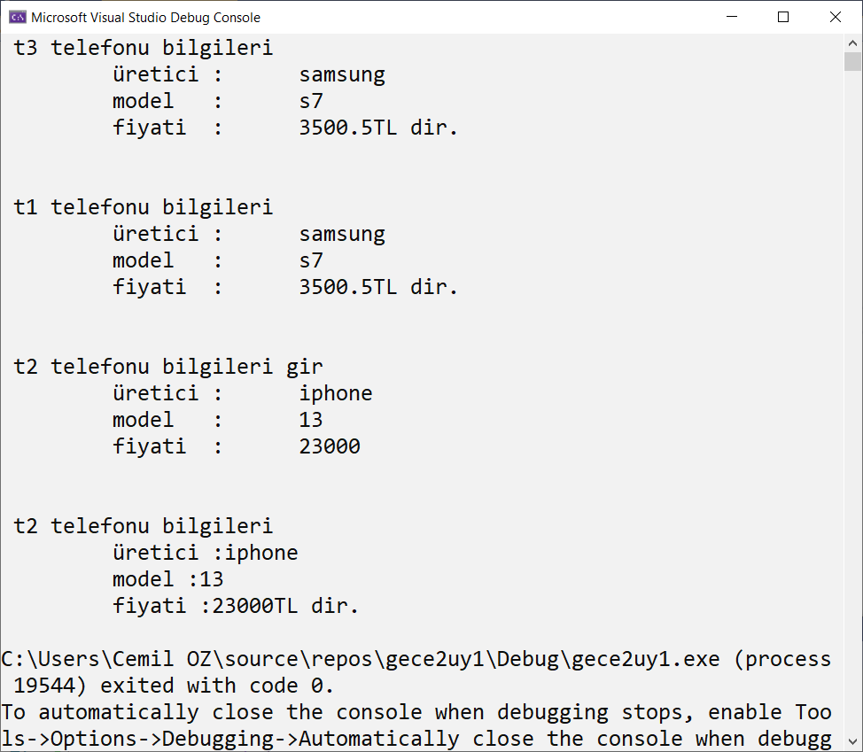

#include <iostream>

#include <locale.h>

using namespace std;

struct cepTelefonu

{

string uretici;

string model;

float fiyat;

};

int main()

{

setlocale(LC_ALL, "Turkish");

cepTelefonu t1, t2;

cepTelefonu t3 = { "samsung","s7",3500.50f };

cout << "\n\n t3 telefonu bilgileri " << endl;

cout << "\t üretici :\t" << t3.uretici << endl;

cout << "\t model :\t" << t3.model << endl;

cout << "\t fiyati :\t" << t3.fiyat << "TL dir." << endl;

t1 = t3;

cout << "\n\n t1 telefonu bilgileri " << endl;

cout << "\t üretici :\t" << t1.uretici << endl;

cout << "\t model :\t" << t1.model << endl;

cout << "\t fiyati :\t" << t1.fiyat << "TL dir." << endl;

cout << " \n\n t2 telefonu bilgileri gir " << endl;

cout << "\t üretici :\t"; cin >> t2.uretici;

cout << "\t model :\t"; cin >> t2.model;

cout << "\t fiyati :\t"; cin >> t2.fiyat;

cout << "\n\n t2 telefonu bilgileri " << endl;

cout << "\t üretici :" << t2.uretici << endl;

cout << "\t model :" << t2.model << endl;

cout << "\t fiyati :" << t2.fiyat << "TL dir." << endl;

return 0;

}

#include <iostream>

#include <locale.h>

using namespace std;

struct cepTelefonu

{

string uretici;

string model;

float fiyat;

};

void yazdir(cepTelefonu t, string s); //fonksiyon bildirimi

cepTelefonu oku();

int main()

{

setlocale(LC_ALL, "Turkish");

cepTelefonu t1[] = { {"samsung","s7",3500.50f},{"samsung","s7",2000.50f },{"samsung","s7",3500.50f} };

for (int i = 0; i < 3; i++)

{

if (t1[i].fiyat > 3000)

yazdir(t1[i], " telefon ");

}

}

cepTelefonu oku()

{

cepTelefonu t;

cout << "\n\n telefon bilgileri gir " << endl;

cout << "\t üretici :"; cin >> t.uretici;

cout << "\t model :"; cin >> t.model;

cout << "\t fiyati :"; cin >> t.fiyat;

return t;

}

void yazdir(cepTelefonu t, string s)

{

cout <<'\n'<< s << " telefonu bilgileri " << endl;

cout << "\t üretici :" << t.uretici << endl;

cout << "\t model :" << t.model << endl;

cout << "\t fiyati :" << t.fiyat << "TL dir." << endl;

}

#include <iostream>

#include <locale.h>

using namespace std;

struct cepTelefonu

{

string uretici;

string model;

float fiyat;

};

void yazdir(cepTelefonu t, string s); //fonksiyon bildirimi

cepTelefonu oku();

int main()

{

setlocale(LC_ALL, "Turkish");

const int eleman = 20;

int n;

//cepTelefonu t1[] = { {"samsung","s7",3500.50f},{"samsung","s7",2000.50f },{"samsung","s7",3500.50f} };

cepTelefonu t1[eleman];

cout << " \n kaç telefon girilecek (max 20) ? "; cin >> n;

if (n > eleman)

n = eleman;

for (int i = 0; i < n; i++)

t1[i] = oku();

for (int i = 0; i < 3; i++)

{

if (t1[i].fiyat > 3000)

yazdir(t1[i], " telefon ");

}

}

cepTelefonu oku()

{

cepTelefonu t;

cout << "\n\n telefon bilgileri gir " << endl;

cout << "\t üretici :"; cin >> t.uretici;

cout << "\t model :"; cin >> t.model;

cout << "\t fiyati :"; cin >> t.fiyat;

return t;

}

void yazdir(cepTelefonu t, string s)

{

cout <<'\n'<< s << " telefonu bilgileri " << endl;

cout << "\t üretici :" << t.uretici << endl;

cout << "\t model :" << t.model << endl;

cout << "\t fiyati :" << t.fiyat << "TL dir." << endl;

}

Bir boyutlu dizi uygulaması

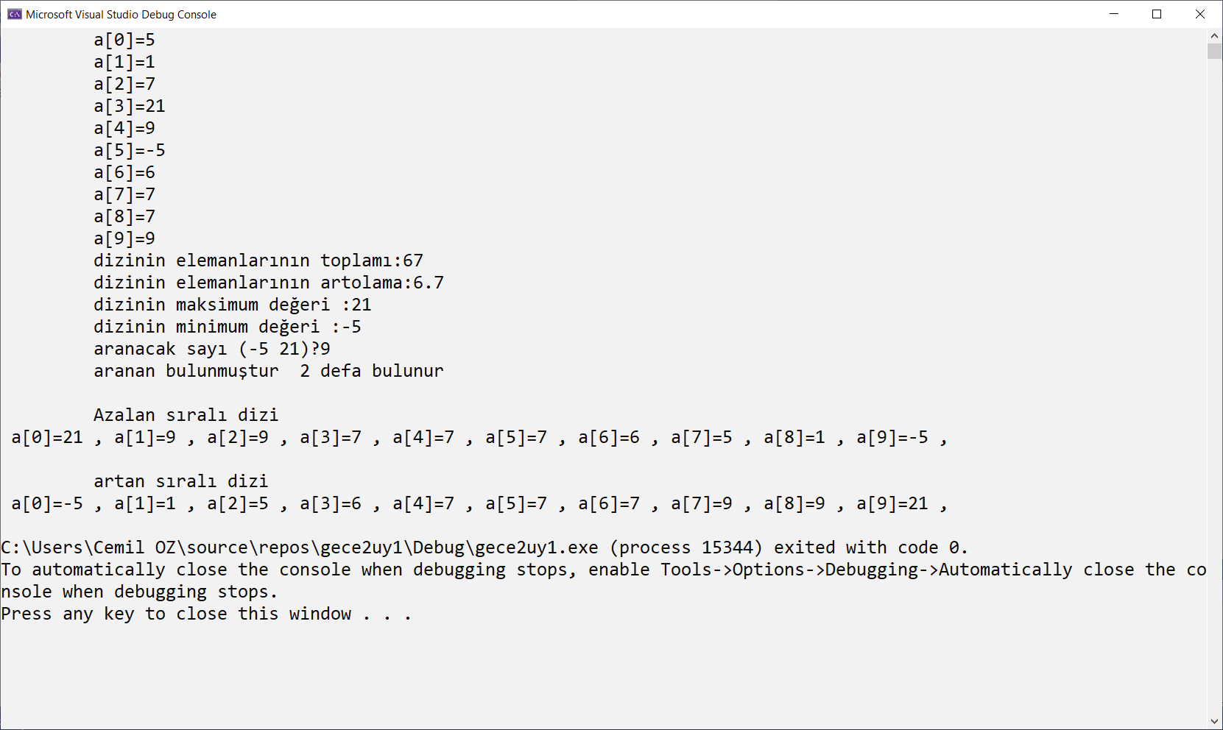

#include <iostream>

#include <locale.h>

using namespace std;

int main()

{

setlocale(LC_ALL, "Turkish");

const int eleman = 10;

int toplam = 0;

int a[eleman] = { 5,1,7,21,9,-5,6,7,7,9 };

// diziyi yazdır ma

for (int i = 0; i < eleman; i++)

cout << "\t a[" << i << "]=" << a[i] << endl;

// dizinin elemanlarını topla

for (int i = 0; i < eleman; i++)

toplam += a[i];

cout << " \t dizinin elemanlarının toplamı:" << toplam << endl;

cout << " \t dizinin elemanlarının artolama:" << (float)toplam/eleman << endl;

// dizinin en büyük elemanını bulma

int max = a[0];

for (int i = 0; i < eleman; i++)

{

if (a[i] > max)

{

max = a[i];

}

}

cout << " \t dizinin maksimum değeri :" << max << endl;

//dizinin en küçük değerini bulma

int min = a[0];

for (int i = 0; i < eleman; i++)

{

if (a[i] <min)

{

min = a[i];

}

}

cout << " \t dizinin minimum değeri :" << min << endl;

//dizi içerisinde arama

int data;

cout << "\t aranacak sayı (-5 21)?";

cin >> data;

int sayac = 0;

for (int i = 0; i < eleman; i++)

{

if (a[i] == data)

{

sayac++;

}

}

if (sayac == 0)

cout << "\aranan bulunamamıştır " << endl;

else

cout << "\t aranan bulunmuştur " << sayac<< " defa bulunur"<< endl;

// dizi sıralama büyükten küçüğe

for (int i = 0; i < eleman; i++)

{

for (int j = i+1; j < eleman; j++)

{

if (a[i] < a[j])

{

int b = a[j];

a[j] = a[i];

a[i] = b;

}

}

}

// sıralı diziyi yazdır

cout << "\n\t Azalan sıralı dizi" << endl;

for (int i = 0; i < eleman; i++)

cout << " a[" << i << "]=" << a[i] << " ,";

// dizi sıralama küçükten büyükten

for (int i = 0; i < eleman; i++)

{

for (int j = i+1; j < eleman; j++)

{

if (a[i] > a[j])

{

int b = a[j];

a[j] = a[i];

a[i] = b;

}

}

}

// sıralı diziyi yazdır

cout << "\n\n\t artan sıralı dizi" << endl;

for (int i = 0; i < eleman; i++)

cout << " a[" << i << "]=" << a[i] <<" ,";

cout << endl;

return 0;

}

#include <iostream>

using namespace std;

void printArray(int a[], int n);

int sumArray(int a[], int n);

int ArrayMax(int a[], int n);

int ArrayMin(int a[], int n);

float ArrayAvarage(int a[], int n);

int SearchArray(int a[], int n, int data);

int main()

{

int a[] = { 0,1,2,3,4,5,6,7,8,9 };

printArray(a, 10);

cout << " sum of array element= " << sumArray(a, 10) << endl;

cout << " maxsimum value of array= " << ArrayMax(a, 10) << endl;

cout << " minimum value of array= " << ArrayMin(a, 10) << endl;

cout << " Avarege value of array= " << ArrayAvarage(a, 10) << endl;

cout << " searching 5 in array= " << SearchArray(a, 10, 5) << endl;

return 0;

}

void printArray(int a[], int n)

{

for (int i = 0; i < n; i++)

cout <<"\t a["<<i<<"]="<<a[i] << endl;

}

int sumArray(int a[], int n)

{

int sum = 0;

for (int i = 0; i < n; i++)

sum+=a[i];

return sum;

}

int ArrayMax(int a[], int n)

{

int max =a[0] ;

for (int i = 0; i < n; i++)

{

if (a[i] > max)

{

max = a[i];

}

}

return max;

}

int ArrayMin(int a[], int n)

{

int min = a[0];

for (int i = 0; i < n; i++)

{

if (a[i] < min)

{

min = a[i];

}

}

return min;

}

float ArrayAvarage(int a[], int n)

{

int sum = 0;

for (int i = 0; i < n; i++)

sum += a[i];

return (float)sum/10;

}

int SearchArray(int a[], int n,int data)

{

for (int i = 0; i < n; i++)

{

if (a[i] == data)

{

cout << " data found ";

return i;

}

}

cout << " not found";

return 0;

}

// char.cpp : This file contains the 'main' function. Program execution begins and ends ther

#include <iostream>

using namespace std;

int giveSize(char ch[]);

int findChar(char ch[], char chf);

int main()

{

char ch[] = "bugun hava cok soguk";

cout << " element number =" << giveSize(ch) << endl;

cout << " a " << " frequency is " << findChar(ch, 'a');

}

int giveSize(char ch[])

{

int i = 0;

while (ch[i] != '\0')

i++;

return i;

}

int findChar(char ch[], char chf)

{

int c = 0;

for (int i = 0; i < giveSize(ch); i++)

{

if (ch[i] == chf)

{

c++;

}

}

return c;

}

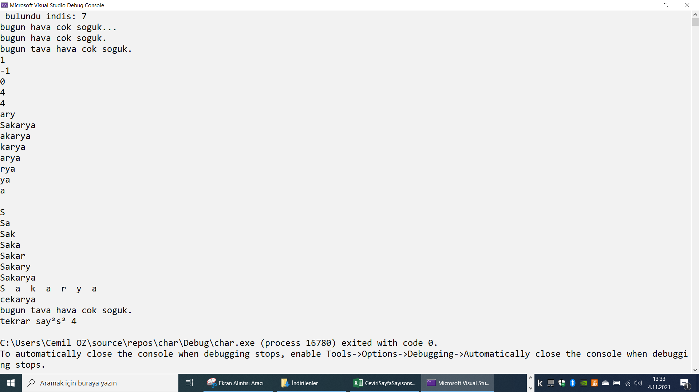

// char.cpp : This file contains the 'main' function. Program execution begins and ends there.

//

#include <iostream>

#include<string>

using namespace std;

int main()

{

string str1 = "bugun hava cok soguk";

size_t n;

n= str1.find("a");

if (n > 0)

cout << " bulundu indis: " << n << endl;

else

cout << " bulunamadı";

str1.append("...");

cout << str1 << endl;

str1.erase(str1.size() - 2, 2);

cout << str1 << endl;

str1.insert(6, "tava ");

cout << str1 << endl;

string str2 = "sakarya";

string str3 = "Sakarya";

cout<<str2.compare(str3)<<endl;

cout<<str3.compare(str2)<<endl;

cout << str3.compare("Sakarya") << endl;

cout<<str3.find_first_of("ry")<<endl;

cout << str3.find_first_not_of("Sak") << endl;

cout << str3.substr(3,3) << endl;

for (int i = 0; i < str3.length(); i++)

cout << str3.substr(i, str3.length() - i)<<endl;

for (int i = 0; i <= str3.length(); i++)

cout << str3.substr(0, i) << endl;

for (int i = 0; i <= str3.length(); i++)

cout << str3.substr(i, 1) <<" ";

str2.replace(0, 2, "ce");

cout <<'\n'<< str2 << endl;

int j = 0;

cout << str1 << endl;

n = str1.find("a");

while(n!=string::npos)

{

j++;

n= str1.find("a",n+1);

}

cout << "tekrar sayısı " << j << endl;

}

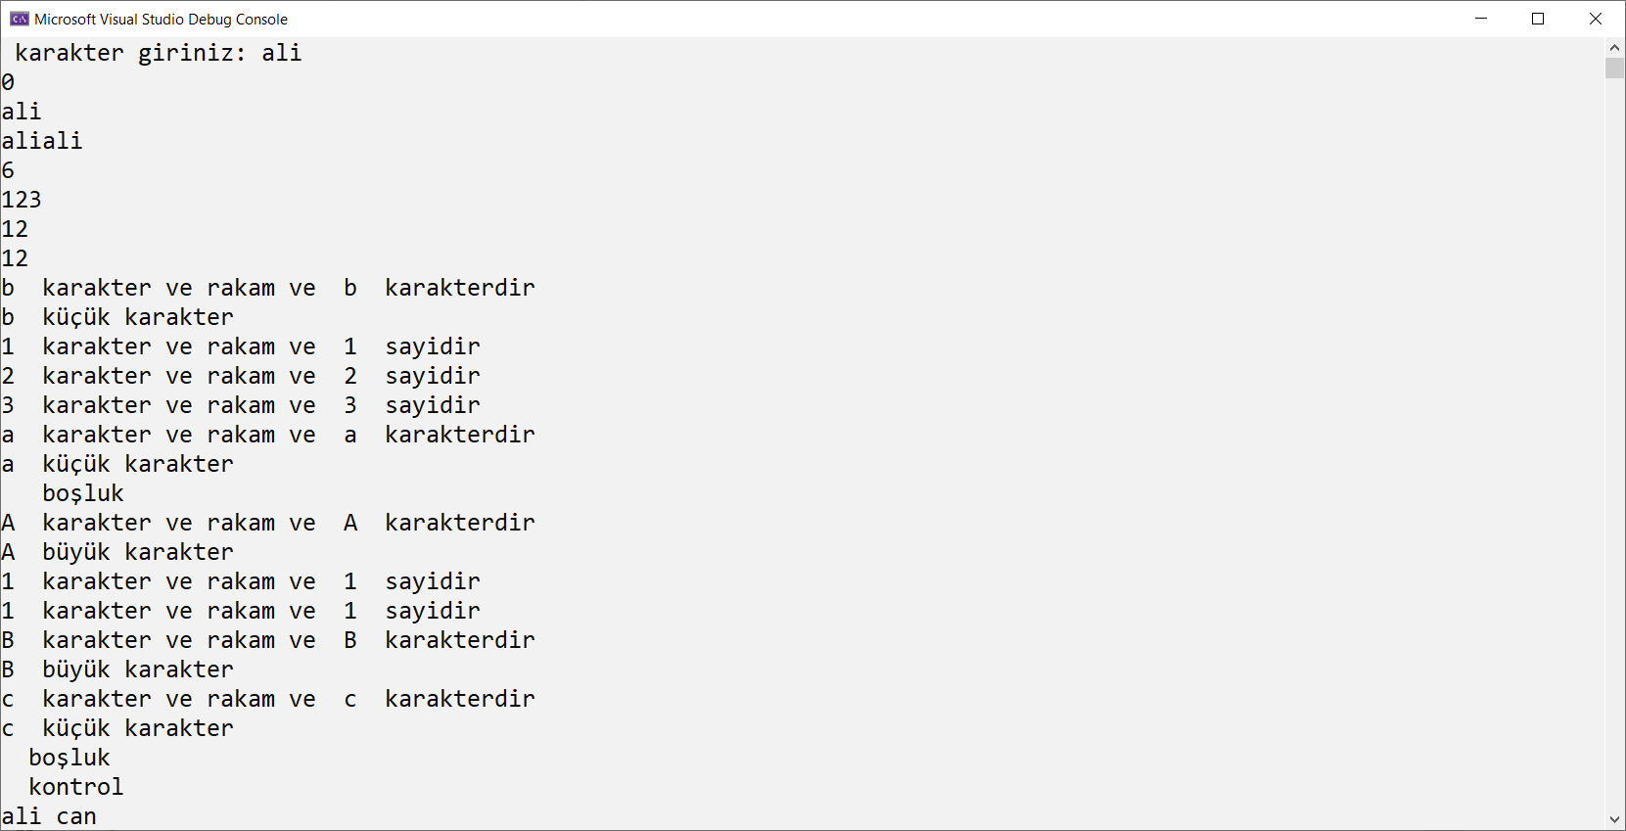

#include <iostream>

//#include <string>

#include <locale.h>

using namespace std;

int main()

{

setlocale(LC_ALL, "Turkish");

char ch1[50], ch2[50], ch3[50];

string str1="b123a A11Bc\r";

cout << " karakter giriniz: ";

//getline(cin, str1);

cin.get(ch1, 50);

strcpy_s(ch2, ch1);

cout<<strcmp(ch2, ch1)<<endl;

cout << ch2 << endl;

strcat_s(ch2, ch1);

cout << ch2 << endl;

cout << strlen(ch2) << endl;

cout << atoi("123") << endl;

double a=strtod("12.18908",NULL) ;

cout << a << endl;

a = atof("12.18908");

cout << a << endl;

for (int i = 0; i < str1.length(); i++)

{

if (isalnum(str1[i]))

{

cout << str1.at(i) << " karakter ve rakam ve " ;

if (isdigit(str1[i]))

cout << str1.at(i) << " sayidir" << endl;

if (isalpha(str1[i]))

cout << str1.at(i) << " karakterdir" << endl;

}

if (islower(str1[i]))

cout << str1.at(i) << " küçük karakter" << endl;

if (isupper(str1[i]))

cout << str1.at(i) << " büyük karakter" << endl;

if (isspace(str1[i]))

cout << str1.at(i) << " boşluk " << endl;

if (iscntrl(str1[i]))

cout << str1.at(i) << " kontrol " << endl;

}

str1 = "aLi CaN";

int i = 0;

for ( i = 0; i < str1.length(); i++)

{

ch1[i]= tolower(str1[i]);

}

ch1[i] = NULL;

cout << ch1 << endl;

for ( i = 0; i < str1.length(); i++)

{

ch1[i] = toupper(str1[i]);

}

ch1[i] = NULL;

cout << ch1 << endl;

return 0;

}

#include <iostream>

#include<string>

using namespace std;

class ogrenci

{

string name;

string lastName;

int age;

public:

ogrenci():name(""),lastName(""),age(0)

{}

ogrenci(string n, string ln, int a) :name(n), lastName(ln), age(a)

{}

void printdata()

{

cout << " student information" << endl;

cout << " name\t:" << name << endl;

cout << " last name\t:" << lastName << endl;

cout << " age\t:" << age << endl;

}

~ogrenci()

{cout<<"died..."<<endl; }

};

int main()

{

ogrenci s1;

ogrenci s2("ali", " oz", 23);

s1.printdata();

s2.printdata();

}

Rastgele şehir bulma

#include <iostream>

#include <locale.h>

using namespace std;

int main()

{

setlocale(LC_ALL, "Turkish");

string gec = "";

string ilRandom[15];

int indis[14] = { 0 };

string iller[31] = { "adana","ankara","adıyaman","bolu","bursa","balıkesir","van","muş","konya","şanlıurfa",

"kahramanmaraş","muğla","mersin","karaman","sakarya","bileck","eskişehir","çorum","çankırı","çanakkale",

"edirne","izmir","istanbul","tekirdağ","kırklareli","kocaeli","yozgat","amasya","antalya","denizli","aydın"};

int min = iller[0].length();

for (int i = 0; i < 31; i++)

{

if (min > iller[i].size())

min = iller[i].size();

}

int max= iller[0].size();

for (int i = 0; i < 31; i++)

{

if (max < iller[i].size())

max = iller[i].size();

}

cout << " min :" << min << endl;

cout << " mak :" << max << endl;

int control = 0;

for (int i = min;i < max; i++)

{

cout << i << ",";

if (control == 0 && i!=min)

cout << "bulunamadı" << endl;

for (int j = 0; j < 1000000; j++)

{

int control = 0;

//cout << j << " ";

for (int s = 0; s < i; s++)

{

ilRandom[s] = iller[rand() % 31];

//cout << ilRandom[s] << endl;

}

int ming = ilRandom[0].length();

for (int k = 0; k < i; k++)

{

if (ming > ilRandom[k].length())

ming= ilRandom[k].length();

}

//cout << ming << endl;

for (int k = 0; k < ming; k++)

{

gec = "";

for(int t=0;t<i;t++)

gec += ilRandom[t].at(k);

//cout << gec << endl;

for (int x = 0; x < 31; x++)

{

if (iller[x] == gec)

{

cout << gec << endl;

control=1;

}

}

}

if (control == 1)

break;

}

}

}